Northeast Shellfish Sanitation Association
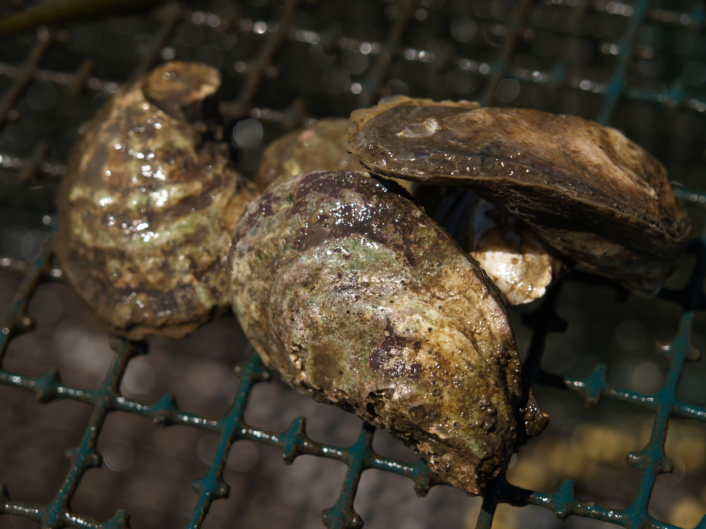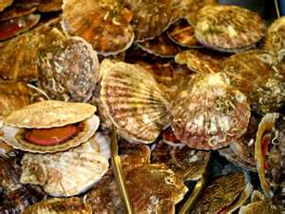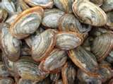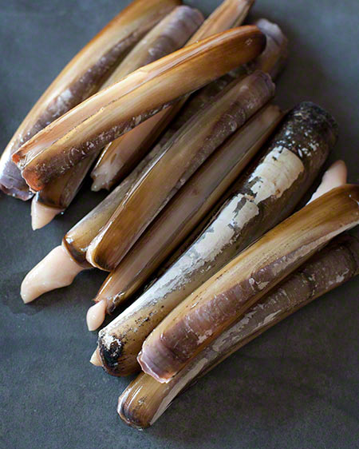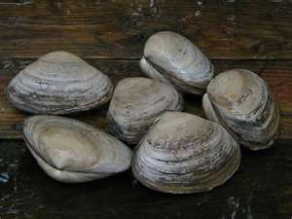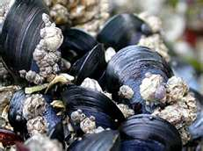
Tuesday, March 8th
8:00 – 8:35 Continental Breakfast and Registration
8:35 – 8:45 Welcome - Chris Nash, Shellfish Program Manager, NH Department of

Environmental Services
Restoration and Industry Development
8:45 – 9:15 Ray Grizzle - University of New Hampshire
Coupling Shellfish Aquaculture with Restoration Activities
9:15 – 9:45 Ray Konisky - The Nature Conservancy
A Shellfish Restoration Case Study of the Oyster River, Durham, NH
9:45 – 10:15 Don Keirstead - Natural Resource Conservation Service
Federal Funding Opportunities to Join Restoration and Industry Development
10:15 - 10:30 Break
10:30 – 11:00 Krystin Ward - University of New Hampshire
New Hampshire Oyster Conservationist Program
11:00 – 11:30 Chris Davis - East Coast Shellfish Growers Association
New Developments in Oyster Farm Technology
11:30 – 12:30 LUNCH
Nutrient Bioextraction

12:30 – 1:30 Jeannie Brochi – United States Environmental Protection Agency
Federal Perspectives on Nitrogen Bioextraction in the Regulatory World of
NPDES Permits and Nonpoint Source Controls
1:30 – 2:00 Rich Langan – University of New Hampshire
Opportunities for Shellfish Restoration, Aquaculture Development and
Nitrogen Removal in Estuarine Waters
2:00 – 2:30 Ray Grizzle – University of New Hampshire
Nitrogen Removal in New Hampshire Oyster Reefs
2:30 – 2:45 Break
2:45 – 3:15 Bob Rheault – Long Island Sound Study
3:15 – 4:30 Dorothy Leonard and Sandy Macfarlane - Ocean Equities LLC
Audience Participation Workshop: Shellfish Restoration Best Practices

Northeast Shellfish Sanitation Association
Tuesday, March 8th
NESSA Business Meeting

4:30 – 4:45 Chris Nash - New Hampshire Department of Environmental Services
NESSA Business Meeting
4:45 ADJOURN
5:00 – 7:00 REception - To include fresh local oyster’s presented by Little Bay and Island Creek Oyster Companies, hors d’oeuvres and desserts

Northeast Shellfish Sanitation Association
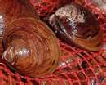

Wednesday, March 9th
8:00 – 8:40 Continental Breakfast and Registration
8:40 – 8:45 Opening Remarks – Chris Nash, Shellfish Program Manager
NH Department of Environmental Services
Red Tide Disaster Relief Grant / PSP Toxins
8:45 – 9:15 Carol Elliott – New Hampshire Department of Environmental Services
New Hampshire Red Tide Disaster Relief Grant Project Overview
9:15 – 9:45 Don Anderson - Woods Hole Oceanographic Institution
Gulf of Maine PSP Modeling with an Overview of the 2010 Cyst Map Cruise
9:45 – 10:15 Darcie Couture – Maine Department of Marine Resources
Regional Analysis of PSP Toxins in Gulf of Maine Lobster Tomalley and
Exports to Japan
10:15 – 10:30 Break
10:30 – 11:00 Stacey Degrasse - United States Food and Drug Administration
Onboard and Dockside PSP Testing of Shellfish Harvested from
Federally Closed Waters

11:00 – 12:00 Round Table Discussion - Onboard and Dockside PSP Testing
Moderator - Mike Hickey, Massachusetts Division of Marine Fisheries

12:00 – 1:00 LUNCH

FDA / ISSC Reports on Current Issues
1:00 – 1:30 Ken Moore, Executive Director – Interstate Shellfish Sanitation Conference
ISSC Update

1:30 – 2:00 Paul DiStefano - United States Food and Drug Administration
FDA Headquarters Update and Vv/Vp Issues

2:00 – 2:30 Greg Goblick – United States Food and Drug Administration
Progress on Waste Water Treatment Facility Viral Coliphage Studies

2:30– 2:45 Break

Northeast Shellfish Sanitation Association

Wednesday, March 9th

NESSA State Reports
2:45 – 3:00 State Reports - Connecticut
3:00 – 3:15 State Reports - Maine
3:15 – 3:30 State Reports - massachusetts
3:30 – 3:45 State Reports - New Jersey
3:45 – 4:00 State Reports - new york
4:00 – 4:15 State Reports - rhode island
4:15 – 4:30 State Reports - Vermont
4:30 – 4:45 State Reports - New Hampshire
4:45 Closing Remarks - ADJOURN

