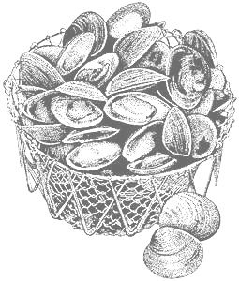
2011 Annual Meeting
March 8th – March 9th
Seacoast Science Center
Rye, NH

Northeast Shellfish
Sanitation Association

Hotel List

Anchorage Inns & Suites - Portsmouth, NH – Located 5.5 miles from SSC - $89.00 – $102.00 per night
Best Western Wynwood Hotel - Portsmouth, NH - Located 5.5 miles from SSC - $89.00 – $102.00 per night
Comfort Inn Portsmouth – Portsmouth - Located 3.2 miles from SSC - $77.00 - $99.00 per night
Courtyard by Marriott - Portsmouth, NH - Located 5.5 miles from SSC - $102.00 - $139.00 per night
Fairfield Inn by Marriott - Portsmouth, NH - Located 5 miles from SSC - $99.00 - $109.00 per night
Hampton Inn at Portsmouth - Portsmouth, NH - Located 6 miles from SSC - $102.00 - $119.00 per night
Hilton Garden Inn - Portsmouth, NH - Located 3.9 miles from SSC - $102.00 -$159.00 per night
***Valet parking fee of $12.00 per night***
Holiday Inn Portsmouth - Portsmouth, NH - Located 5.5 miles from SSC - $93.00 – $96.00 per night
Sheraton Harborside Hotel - Portsmouth, NH - Located 4.3 miles from SSC - $102.00 – $159.00 per night
***Parking fee of $10.00 per night in outdoor parking and $15.00 per night for garage parking***

