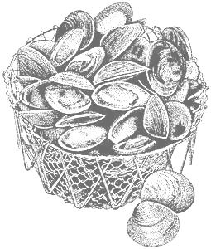
2011 Annual Meeting
March 8th – March 9th
Seacoast Science Center
Rye, NH

Northeast Shellfish
Sanitation Association

Evening Reception Menu
Tuesday March 8th 5-7pm

PASSED HORS D’OEUVRES
Sliced Tenderloin with Horseradish Cream
Tenderloin garnished with a spicy horseradish cream sauce

Maple Glazed Scallop Wrapped in Bacon
Sea scallops wrapped in bacon and baked to perfection with a maple glaze

Large Shrimp Cocktail
Succulent shrimp with zesty cocktail sauce

Sausage Stuffed Mushroom Caps
Fresh mushroom caps stuffed with feta cheese and sausage

Mini Spring Rolls
A combination of vegetables wrapped in a light crisp wrap
Spanikopita
Warm savory pastry with layers of spinach and feta cheese
Cheese, Vegetable and Fruit Platter
Select from a variety of cheese, vegetables and fresh fruit
Dessert Platter
Indulge in a variety of delectable desserts
Fresh Local Oyster Bar
Presented by Little Bay and Island Creek Oyster Companies

Beer and Wine
A variety of beer and wine will be provided
Two drinks per person included in the $20.00 fee

