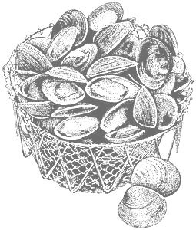
2011 Annual Meeting
March 8th – March 9th
Seacoast Science Center
Rye, NH

Northeast Shellfish
Sanitation Association

REGISTRATION FORM

Please complete and return this form before Friday February 21st via Internet or fax:
Email: Carol.Elliott@des.nh.gov Fax: (603) 559-1510 attn: Carol Elliott

QUESTIONS: Call (603) 559-1508 or email Carol.Elliott@des.nh.gov

Personal Information (Please print clearly):
Title: Mr. Mrs. Ms. Other (Please Specify):
First Name: Last Name:
Organization: Address:
City: State: Zip Code:
Email Address: Telephone:

Registration Fees:
In Person: Video Conference*:
2 Day – $60.00 Single Day – $35.00 March 8th March 9th
Please specify March 8th or March 9th $10.00 per person for one
March 8th March 9th or both days

Evening Reception – March 8th from 5-7 pm – $20.00 - See menu for details

Payment is due at the start of the meeting. For those joining through video conference, payment can be mailed to Carol Elliott – NHDES, 175 International Drive, Suite 222, Portsmouth, NH 03801. Please make checks payable to: NESSA (Northeast Shellfish Sanitation Association).

*Note: A video conference form must be filled out and received by February 17th

For Directions: http://www.seacoastsciencecenter.org/about/contact.php

